Bootstrap Basic & Advanced

1.what are the advantages of bootstrap?

Bootstrap is a widely-used open-source front-end framework for web development that offers several advantages:

-bootstrap is front-end framework.

-basically bootstrap Is used for front-end and it’s free and open source.

-there are different advantages of bootstrap which is given below.

1. bootstrap is widely used in front-end and it’s open source framework, bootstrap is very flexible and easy to use framework .that’s why bootstrap Is also for mobile for device.
2. Bootstrap is very easy to learn and easy to use and also very customize framework for apply and create different font , fonts size screen for better user experience.
3. Bootstrap widely used in css and also for java script . bootstrap is very important for frontend framework.
4. Also bootstrap is also provide different fonts , style , themes and different-different style tools for improving web page look.
5. Bootstrap is open source and also easy for beginners and experts.
6. Bootstrap is also contain best grid view system.

2. What is a Bootstrap Container, and how does it work?

- Bootstrap is a important and very useful tool that used In frontend.

Container is important element that Is used in css and bootstrap.it provide different types style.

Bootstrap container is basically the block and it’s used to store different-different mini container that used to make website and block.

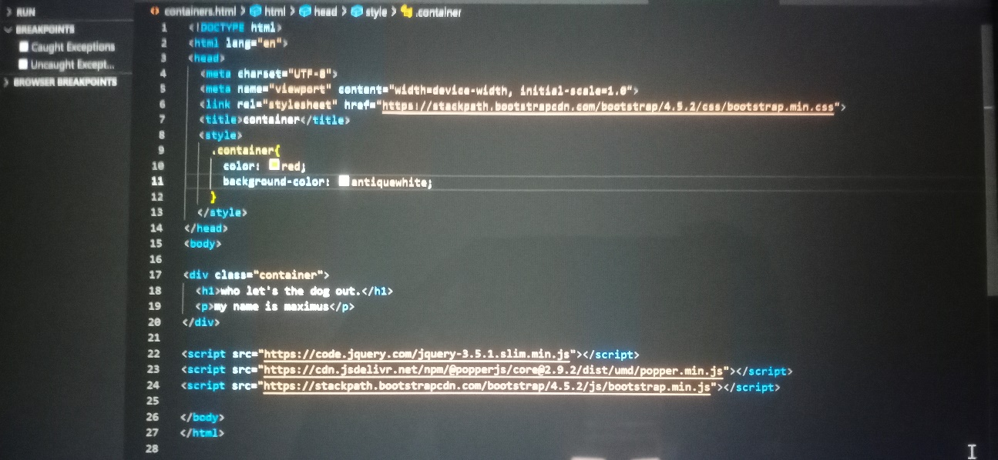

Output:-

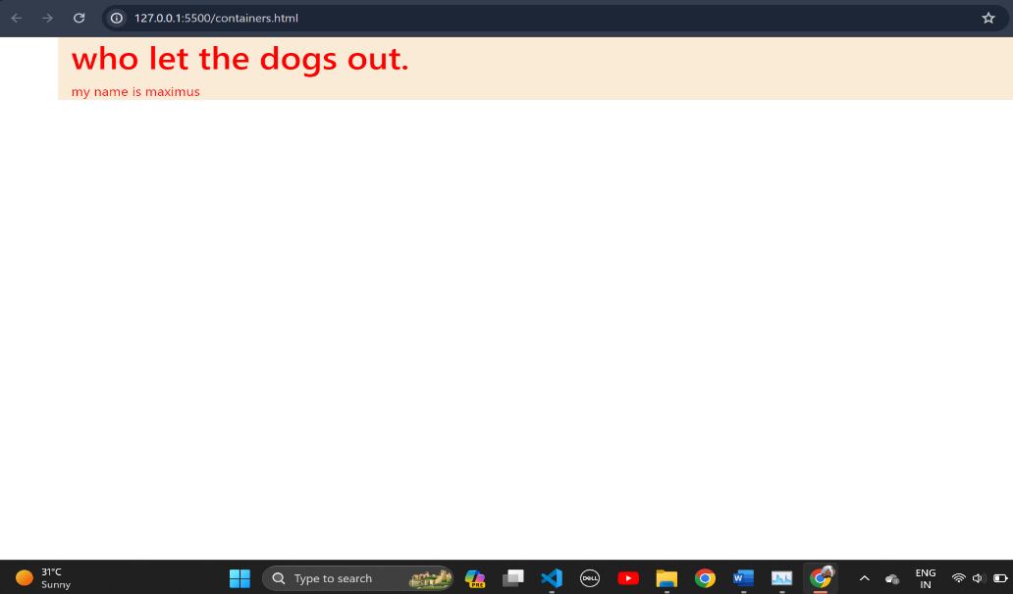

* Container provide a area for making different and customize structure to design the part.
* Container is essential part that used for padding and margin and making the perfect part and perfect website.

3.what are the default bootstrap text settings?

- Bootstrap's default text settings vary slightly depending on the version you're using, but here's a general overview:

Bootstrap text setting is interesting part of bootstrap and it’s based on users and user’s using version.

There is something that everyone have to know about bootstrap text setting.

Font size in bootstrap 5 is default and developer can control and customize them . and in bootstrap text and font default setting Is naturally best for devices.

Link colour is blueish in bootstrap text and it’s also underlined.

Headings is other main things that come under in bootstrap text .there is default text which is <h1> to <h6>.size is increase with upper sets.

There is other different text available like paragraph tag<p> , small<small> , and others <blockquote> , <dl> , <code> etc.

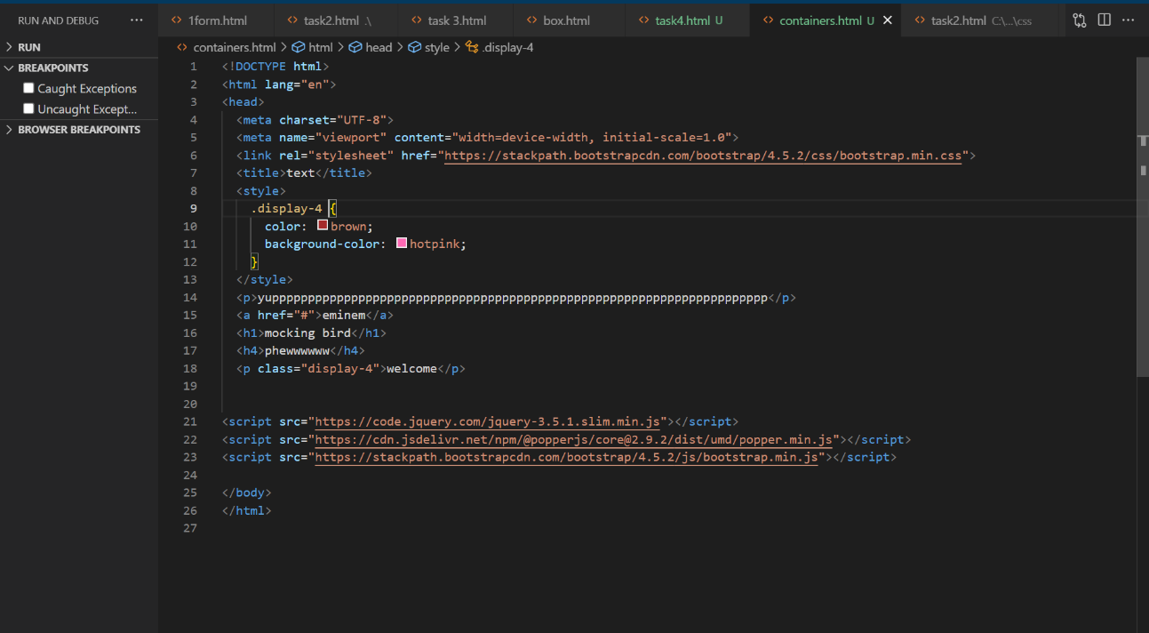

Output:-

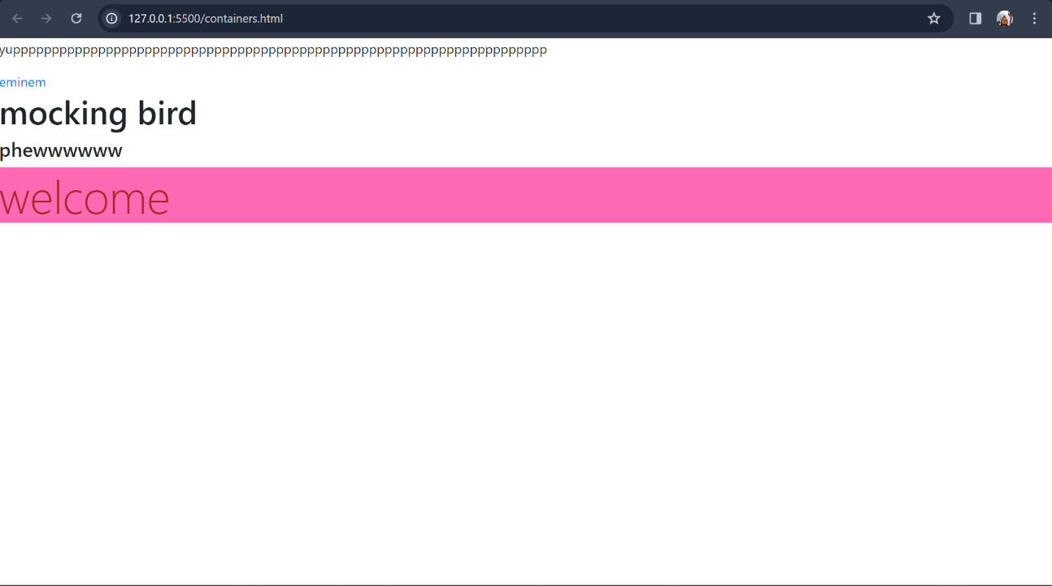

4. What do you know about the Bootstrap Grid System?

- bootstrap is very powerful framework that makes webpages very beautiful. Also bootstrap mater in mobile view system.

Bootstrap is gave us powerful system which is know grid system. Which is gave very powerful and responsive websites and webpages .

This grid system basically based on raw and column system.

basic example of a Bootstrap grid structure:

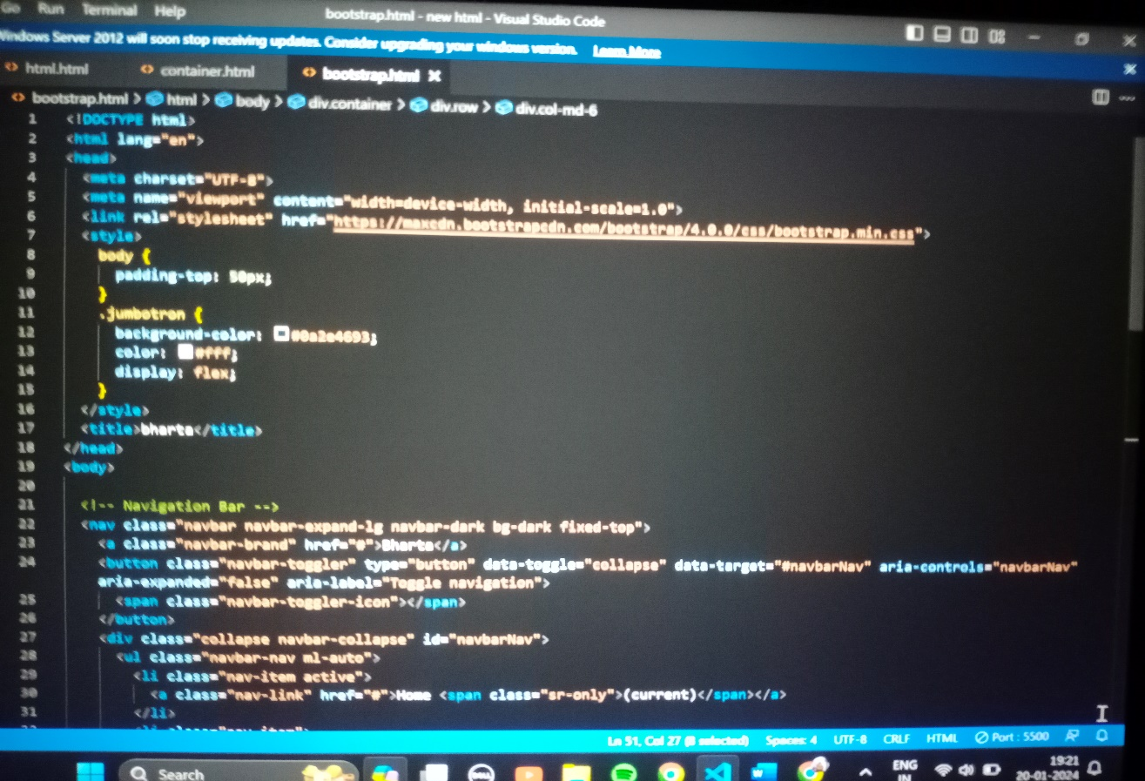

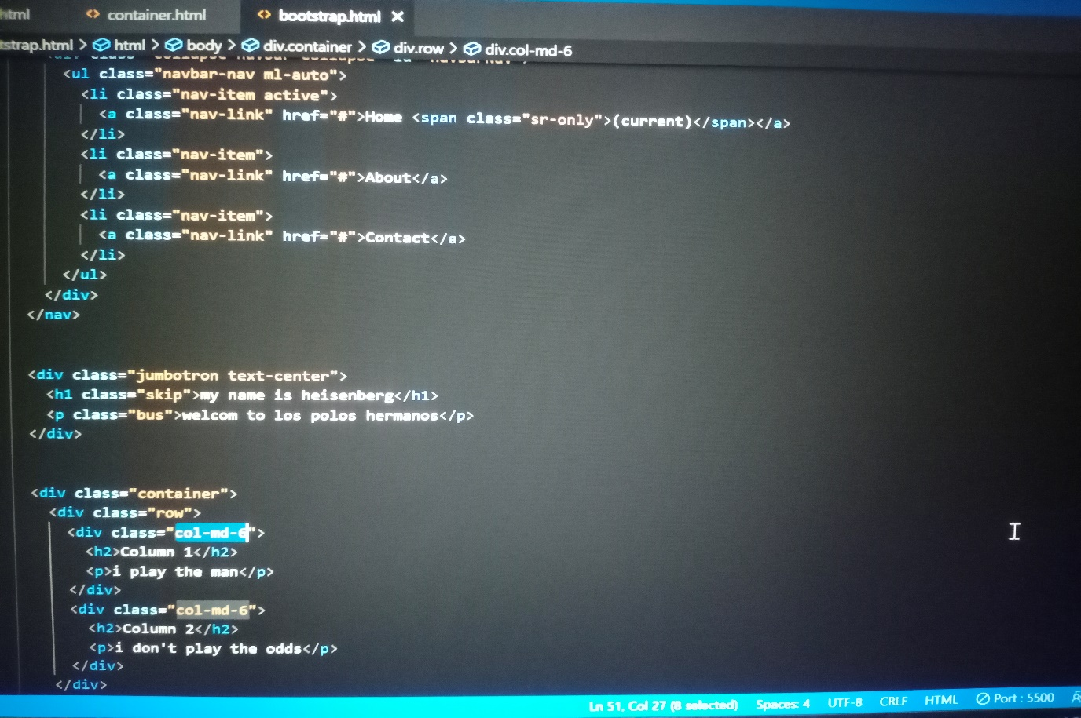

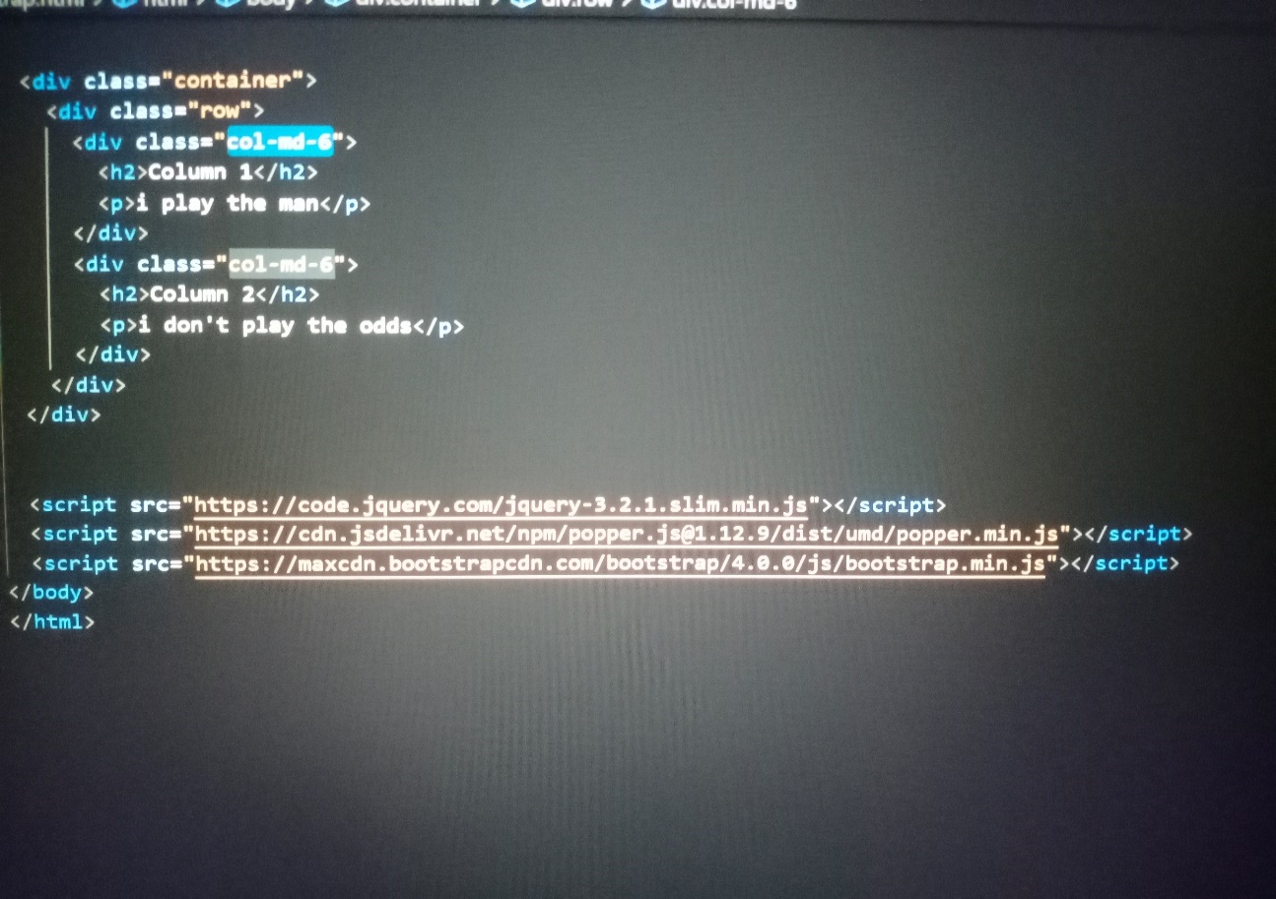

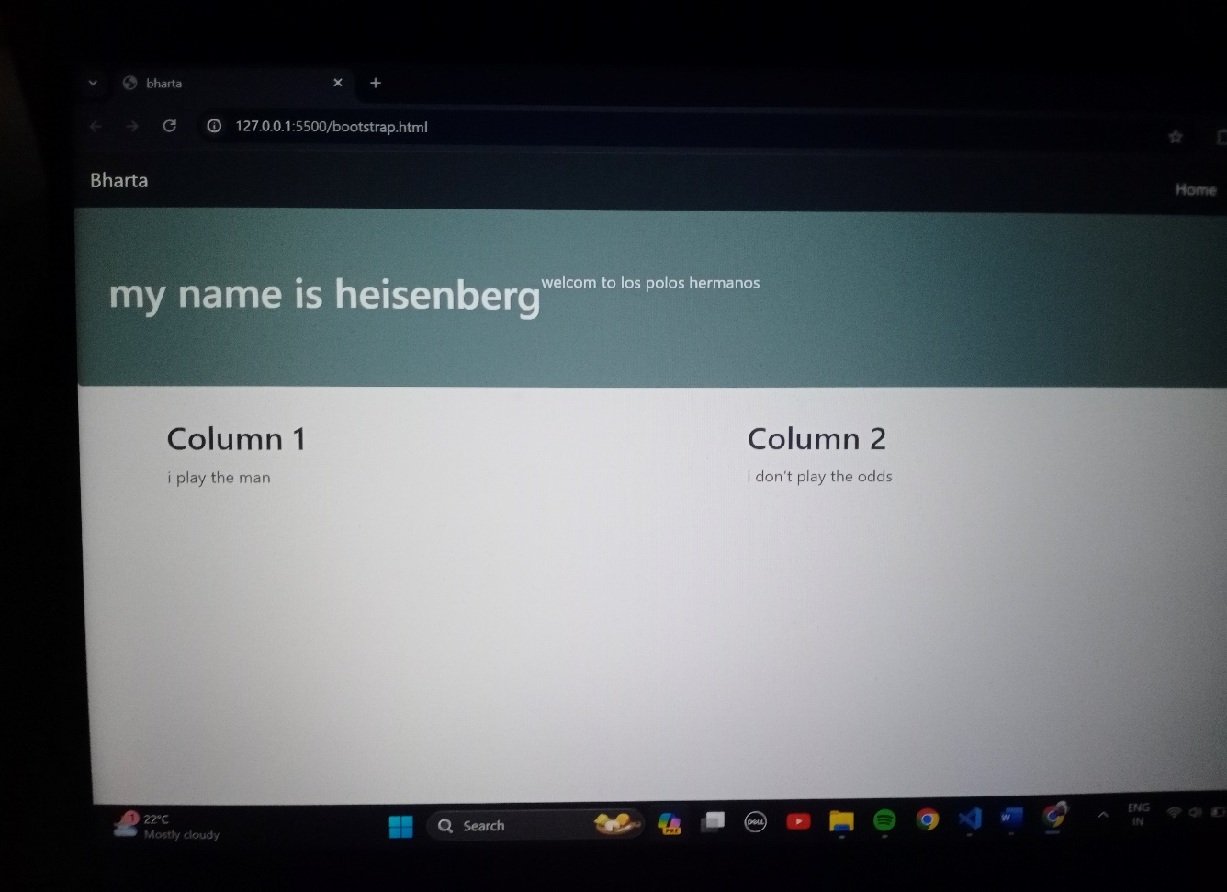

5. What is the difference between Bootstrap 4 and Bootstrap 5

- So bootstrap 4 is old and bootstrap 5 is latest version.

Bootstrap will come with new features and improvement. this is updates was known as bootstrap known as bootstrap 5.

Bootstrap 5 will very powerful and self improved framework update .so their dependency on other things will finish.

Bootstrap is modern and new concept with component like offcanvas .so this is use for creating responsive sidebars.

Customize:

- in the bootstrap 4 support using sass variable for customizations.

- of supporting Api bootstrap Is more customize and accurate with modern concept.

Utility Classes:

- in bootstrap 4 for doing something on text or stylish in elements , bootstrap 4

Put hard work on classes.

- in bootstrap 5 is so flexible and seamless so bootstrap 5 will not take put hard work on classes.

Dependency on other tools:

- Bootstrap 4 was fully dependent for js functionalities.

- when bootstrap 5 will fully independent self-improved which contain self functionalities for JS and also 5 is not dependent on anyone.

controls:

- bootstrap 5 is so advance and gave very unique features that makes webpage and output stylish. So overall output and webpage Is looking more unique and very interesting.

themes

- Bootstrap 5: Improves documentation and introduces a new theme designed to provide a clean and modern look.

Bootstrap 5 is very advance and unique that gave us documentation of user wants unique theme.

7. Grid System:

Bootstrap 5 is basically known for his powerful grid system. And this time grid system will be more better than bootstrap 4.

8. File Size:

- bootstrap 5 is so fast and so flexible . it work so fast and present more precious performance for project.

9. Icons:

- bootstrap 5 support every modern fonts and themes in new update and no more error.

- it also support various new and more unique , modern , stylish icon in new bootstrap.

6. What is a Button Group, and what is the class for a basic B utton Group?

- in latest update of bootstrap which is given ‘btn-group’ for group button class.

This class is used to react and input style and work related group of buttons.

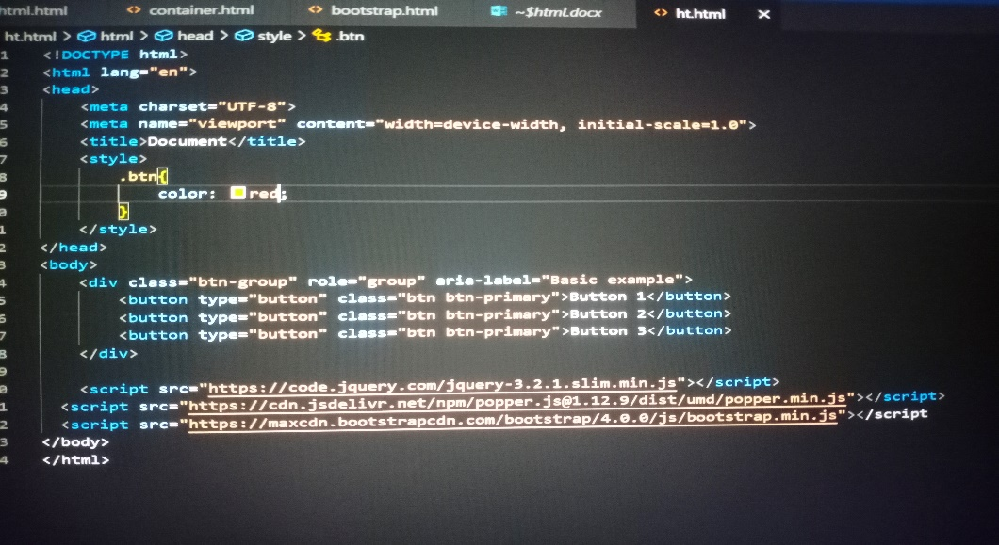

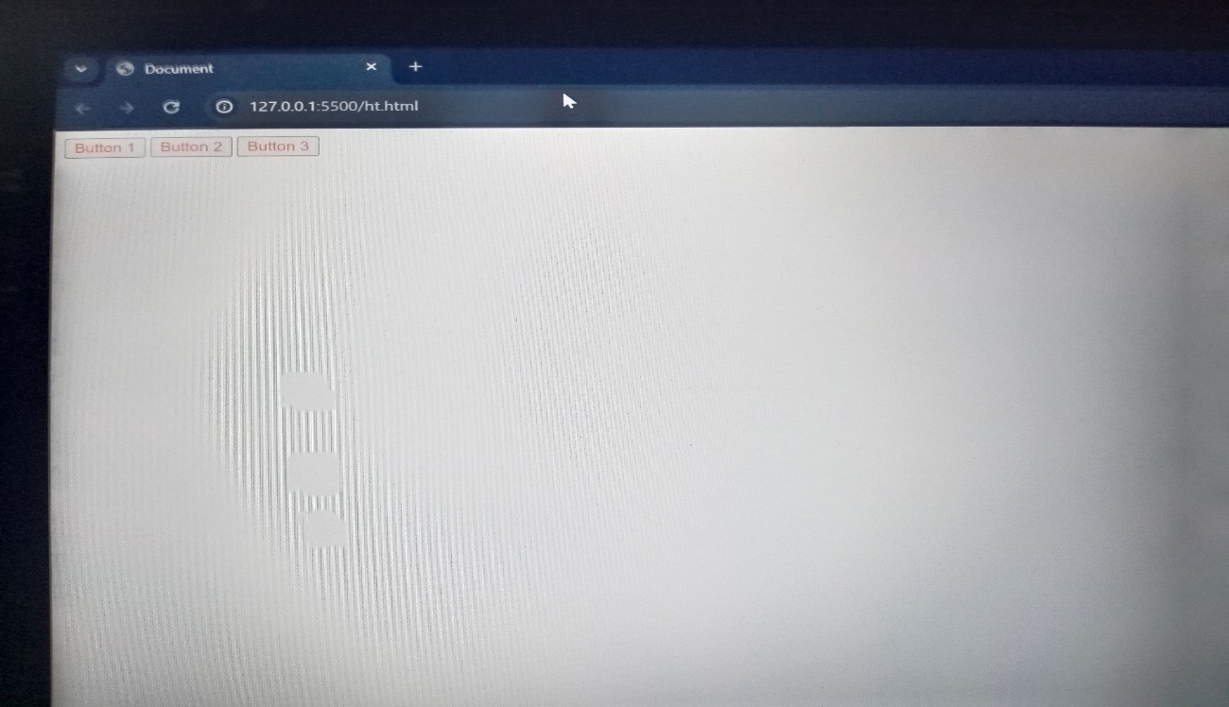

7. How can you use Bootstrap to make thumbnails?

- We can create and operate thumbnail with ‘img’ tag and different other tag .There are different way to create bootstrap thumbnails. like using ‘img’ and other tag.

There Is different way to create thumbnails.

1 Include Bootstrap CSS:

- There are different way to create bootstrap but with css is very important.

To continue that part you have to link that cdn from website and adding that part in head.

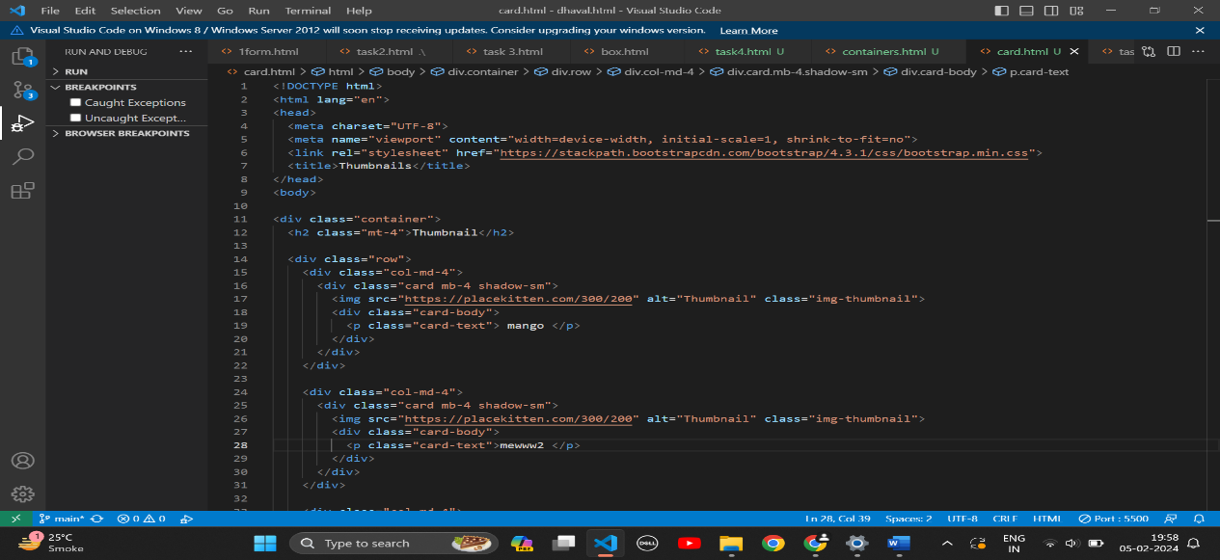

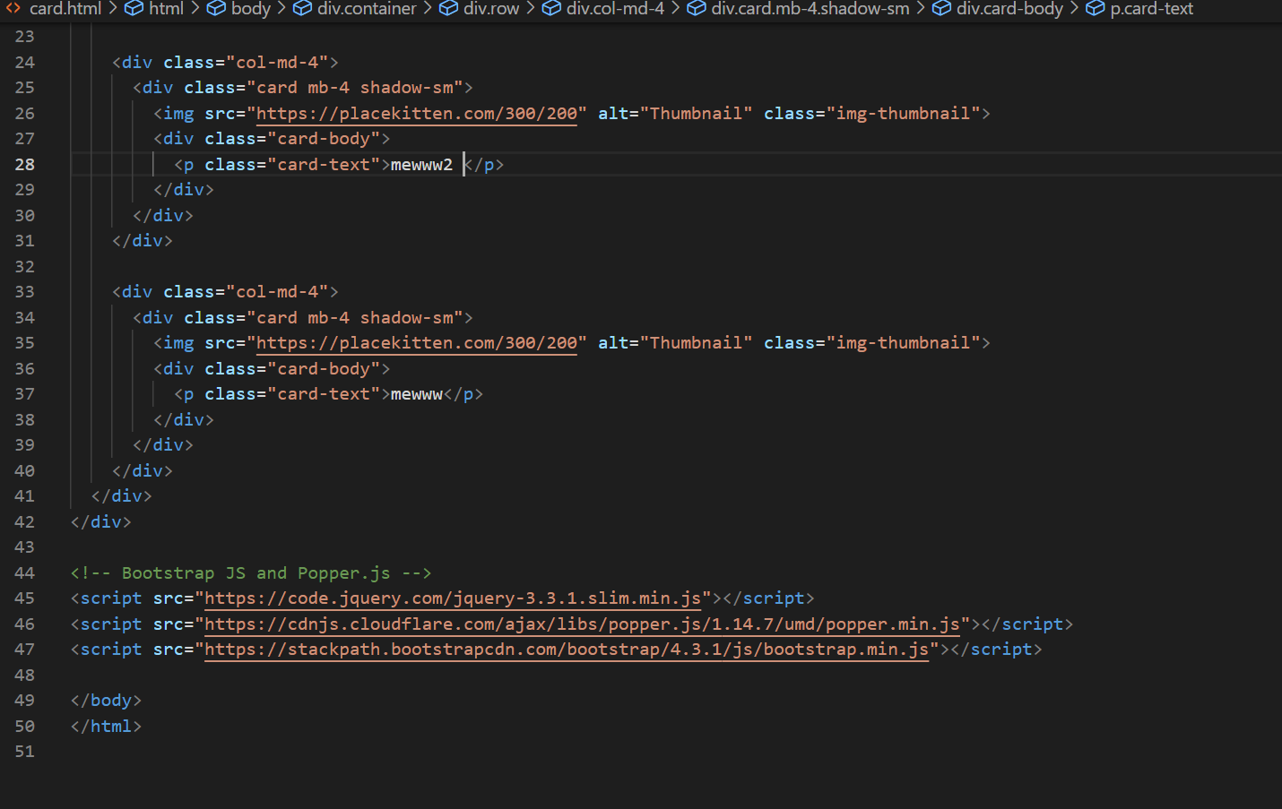

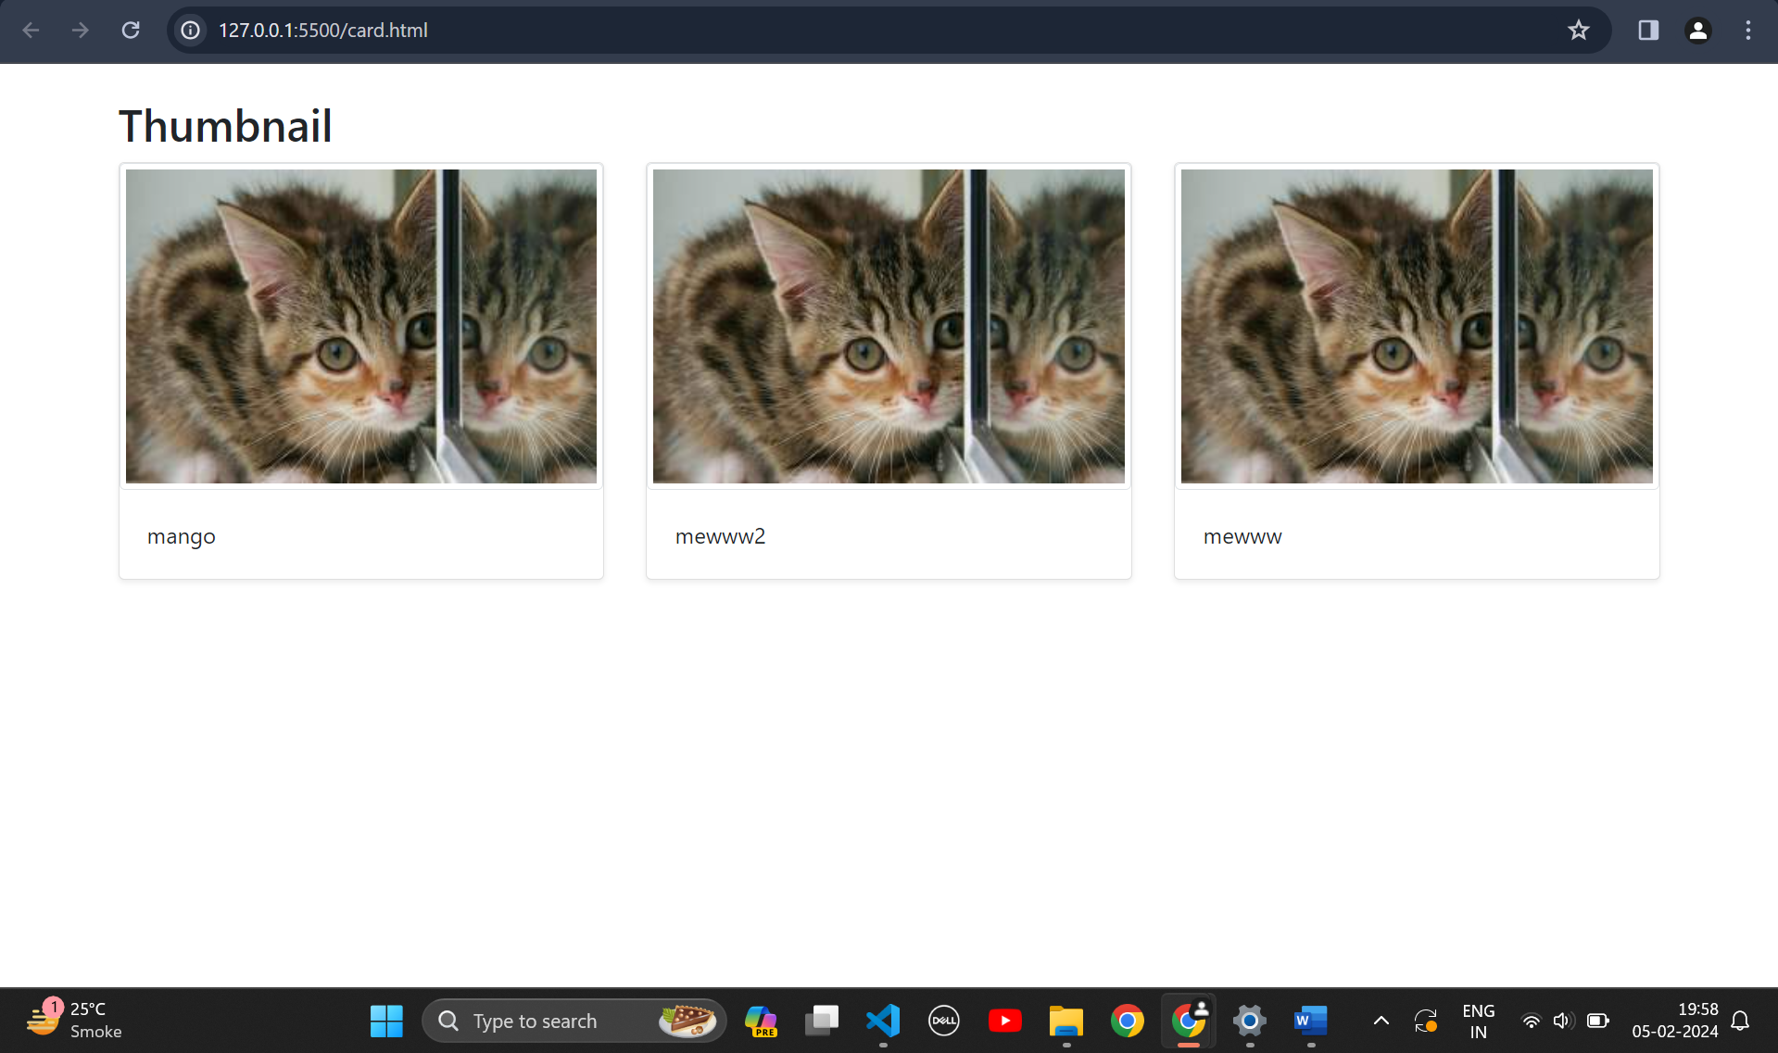

8. In Bootstrap 4, what is flexbox?

- If we want to describe flexbox so the definition of flexbox is layout. Flexbox Is layout module that is used in css and javascript and html basically in frontend.

It’s use for creating powerful and responsive layout deisgn. In bootstrap 4 that is used for powerful responsive web design and layouts.

Flexbox is basically the container that which is used very widely and everywhere in fronted.

Here's a breakdown of what flexbox brings to Bootstrap 4:

**Key functionalities:**

In bootstrap 4 flexbox is very advanced that they can create very customizable and user interest layouts. and its automatically make adjustable manual adjustment.

You can easily create and apply css .

In flexbox its allows you create same height and width item. With equal columns and navigation bars.

8. How can one create an alert in Bootstrap?

-

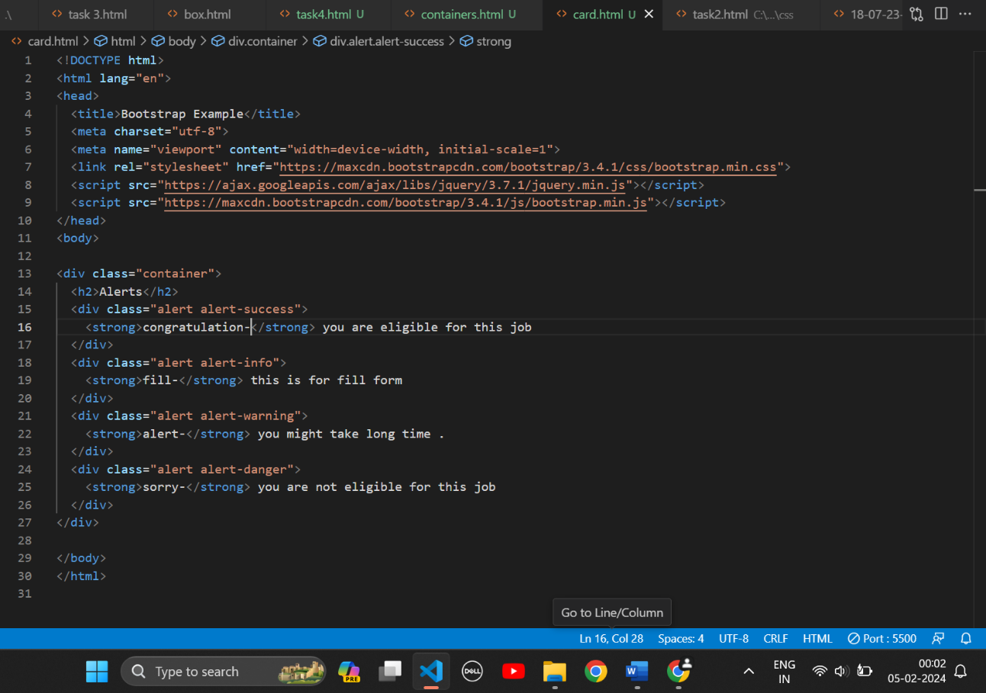

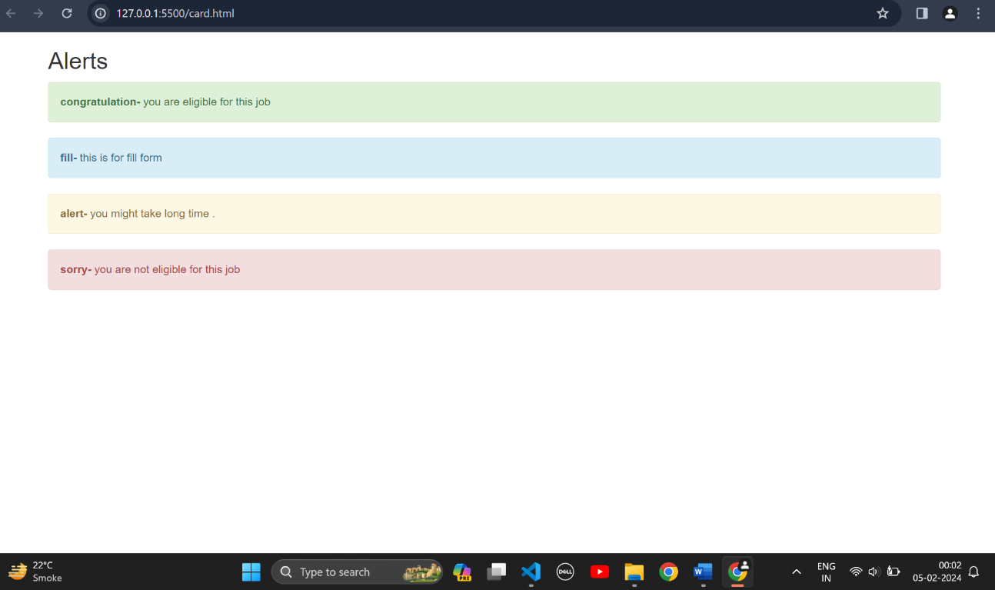

9. What is a bootstrap card and how would you create one?

- bootstrap card is very useful and important part of frontend part that uses widely.

Bootstrap card is tool that using class ‘card’ user and developer can create and customize image , audio and different layouts for pages.

Using bootstrap card developer can create different layout width customize width and dynamically pages card in webpage.

Example:-

